Problems after test :

1.The login link won’t work for some page.

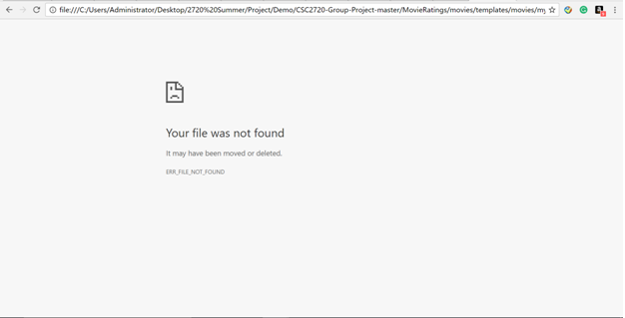

2.Will cause crash if there is a invalid link



3.1Will crash if a string or non integer was inputted in the rating box

🡪3.2 have changed in to buttons, but the rating number sometimes will go beyond 10 or go below 0

🡪3.3 changed in to direct selection of rating points.

4.The Movie list in my list will duplicate if same movie was rated more than once

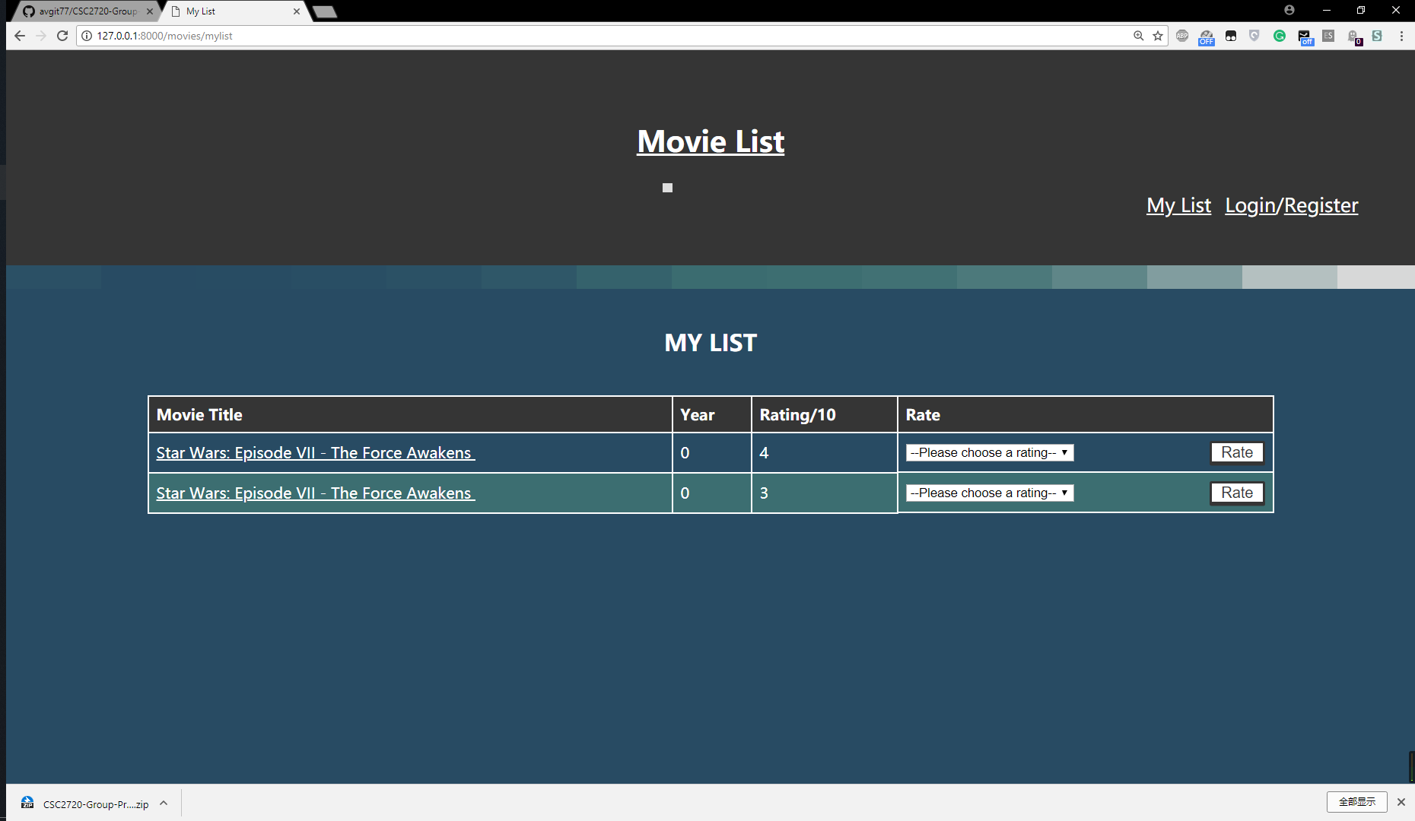

5.A home button needed

6.A Logout Button & function needed

7.The film tape animation might went out for some user.

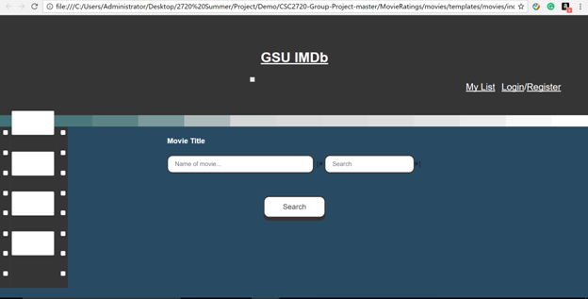

8.Error Forbidden 403 after pressed RATE button.

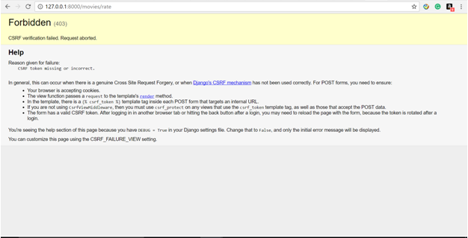

9.There are three logins……

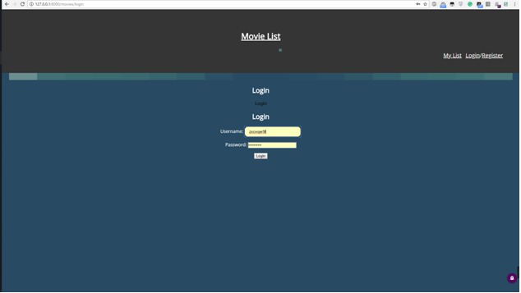

10. would have error if click rate without selecting the rating point.

